City of Leeds Synchronised Swimming Club
Head Coach Report 2016-2017
Sarah Speers
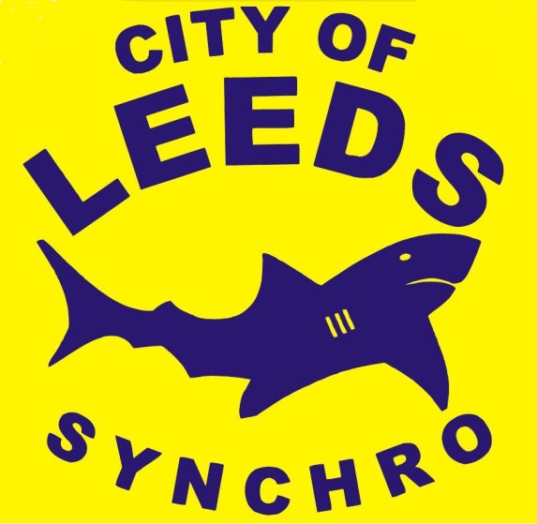

A year of change
2016-2017 has been a year of change, and also therefore challenges and opportunities.
There have been changes to the sport Nationally this year including Grades, competition structure, Judging structure, and coaching qualifications.
In addition, all Beacon funding for programmed including COL and LCC has now finished, and there are no opportunities presented currently to replace this in the future.
This season has also been hugely successful not only in competitive performances, but also in the opportunities that athletes have had access to- including club and regional residential at Queen Ethelbergas, an international competition, and a national level competition hosted in Leeds as the Beacon Games.
I would like to say a huge THANKYOU to all the coaches, volunteers, officials, parents and athletes for all their time and support in the programme over the past 12 months to make these achievements possible.
During this report, there is an overview of each topic area in relation to the club.

Grades:
Pass rates since the Grade system has changed have improved greatly. Feedback from parents, coaches and judges alike has been positive. We are still catching up on being able to send swimmers to Grades that they are able to achieve. We require additional judges to be able to do this. We will also start working on routine grades, particularly with the younger swimmers this year.
Competition structure:
Due to changes in the competition structure, It would be great to facilitate two Level 3 competitions for all National Level swimmers to compete at each year. I would like one of these competitions to be a COL open event, to raise the profile of the club, raise funds, provide competition experience for the swimmers and volunteers. If we are to create such an event in 2017, we need to organise this quickly.
Coaching:
Qualified coaches:
- Sarah Speers
- Sue Barrington
- Rosie Barrington
- Gemma Wright
- Abigail Linley
- Fiona Blackstone
- Connor Hill
- Samantha Travis
- Michelle O’Brian
- Liz Jones
- Katerina Holdsworth
- David Entwistle
- Ian Watson
- Lynda Devanny
- Abigail Devanny
- Georgia Fielding
- Deanne Ward

Coaches to join the programme in September:

Chloe McLelland and Angelique Richardson.

It would be great if the club can continue to encourage and support parents and swimmers alike who are interested in becoming coach’s support with their qualifications. Due to changes in circumstances, it is always essential that we continue to recruit coaches who can support the on-going programme.

Judging

There is a real need for additional Level 1, Level 2 and Level 3 Judges to be trained to enable swimmers to attend Grade days and competitions.
Upcoming changes:
In 2018 we will have new FINA figures, and my understanding is that from 2019 there will be a new competition calendar which better suits periodization and planning for developing athletes. This will mean that National Age Groups moves to February. The impact of this is that swimmers, who move up an Age Group in 2019, will have very little time to train this age group, and therefore we need teams of younger swimmers ready to compete at NAGs in February 2019.
Maximum YOB for 2019 Nationals (February)
12&U: 2007
13-15: 2004
15-18: 2001
This means that throughout 2018, we need a team of swimmers of 2007-2008 YOB working towards Grade 3 and a 12&U team if we wish to enter a competitive 12&U team in 2019. These athletes need to be encouraged and developed in Grade 1 and 2 for the remainder of 2017 to enable them to swim in 2018.
Looking at our current membership, we should have sufficient no. of graded athletes to compete in the 13-15 and 15-18 teams in 2019.
England Talent Squads:
Three athletes that train in Leeds SSTS have been selected to England Squads in the September England Trials:
Rebecca Richardson: England Junior and Senior Squad
Greta Hampson: England Junior and Senior Squad
Millicent Costello: England Junior Squad

Tilly Budd was then selected for the Development Squad in England December trials following National Age Groups

- Rebecca Richardson and Greta Hampson have been selected to compete in the French Open and Junior Europeans in 2017 with England Talent.
- Millicent Costello was selected to compete in the Croatia Cup and Junior Europeans in 2017 with England Talent. Millicent Costello came 1st in figures at the Croatia Cup and also in Free Team.
- Tilly Budd will swim in the Development Squad display at the Beacon Games.

Programme development:
- Rebecca Richardson has been selected for TASS and is linked with Leeds University. The S&C coach and physio are already linked with the Synchro Training Scheme which makes the set up, support and communication ideal.

- Head Coach Sarah Speers has completed the Coach+ development programme

- Leeds Beacon programme hosted the Beacon Games in July with great success.

- Level 2 coaching course in York during NER Synchronised Swimming camp in August was a great success, with 8 coaches qualifying at Level 2, including 4 from within the Leeds Synchro Scheme. A local Level 1 course has also been held which has qualified 7 coaches within the scheme

- New Part time physiotherapist in place working with athletes in synchronised swimming and swimming Beacon programmes. This specialist support will improve the injury prevention practices and land training in Leeds, and greatly improve support for England Talent athletes and National level athletes in the talent pool. So far the Physiotherapist has started screening the National squad swimmers. Update: The physio has recently moved to a new post and this has now been filled again for a September start in 2017.

- Beacon programme ran successfully in 2016 with Rosie Barrington leading the coached sessions, and the squad coming 2nd at the Beacon Games. The final two sessions and Beacon games for 2017 squad are coming up in July.

- New links have been developed with Leeds Beckett university to support with Nutrition and psychology going forwards for the Beacon programme/ national squads.

Competition Medal results
Masters Nationals 2016:
Solo (Rosie Barrington)- Gold
Solo (Jeanne Ansley)- Gold
Solo (Sarah Speers)- Bronze
Combination- 4th

Scottish Nationals 2016:
15-18 Figures (Rebecca Richardson)- Gold
15-18 Solo (Rebecca Richardson)- Gold
15-18 Solo (Chloe McLelland)- Bronze
15-18 Duet (Georgia Fielding & Chloe McLelland)- Gold
15-18 Duet (Isobel Davies & Olivia Burton)- Bronze
15-18 Team- Silver

13-15 figures (Millicent Costello)- Silver
13-15 Solo (Millicent Costello)- Silver
12&U figures (Tilly Budd)- Silver
12&U solo (Tilly Budd)- Bronze
12&U Team- Bronze
Hungary Cup 2016:
Combination team- Bronze
Technical team- Bronze
Free team- Bronze
Free duet (Rebecca Richardson & Greta Hampson)- Bronze

National Age Groups 2016:
Overall a very successful competition with COL athletes making the finals in every event for the first time (in all solos, duets and teams)
13-15 figures (Millicent Costello)- Silver
13-15 solo (Millicent Costello)- Bronze
15-18 solo (Rebecca Richardson)- Bronze
18/19 figures (Alyssa Ward)- Silver
18/19 solo (Alyssa Ward)- Silver

There are plans to hold a club camp in October half term for all athletes competing at NAGs to support in team bonding and preparation for swimming at NAGs. This has proven very successful for athletes competing at British Championships and we feel this could have the same positive effect on performances at NAGs for all teams, routines and figures in 2017.

British Championships 2017:
Best results to date for COL with great increases in scores from 2016 and cementing COL in 3rd place in team events in Britain, an amazing achievement.
Technical Team- Bronze
Combination Team- Bronze
Free Team- Bronze
Technical Solo (Rebecca Richardson)- Silver
Free Solo (Rebecca Richardson)- Bronze
Figures (Rebecca Richardson)- Bronze
Free Duet (Rebecca Richardson & Millicent Costello)- Silver

Beacon Network
- Clubs engaged in the Network- Leeds Mermaids SSC, Pudsey Pearls SSC, BOK SSC, Halifax SSC, Gateshead SSC (5) All five clubs are active in feeding athletes into the daily training squad to reach national level, and have coaches attending sessions/ attend development meetings.

Employment
With the Beacon Programme and funding now finished, there is no longer a SLA in place with LCC. Therefore, maintaining the current Full time coach and Part Time coach is reliant on the sustainability of the LCC Synchronised Swimming Training Scheme.
A new business plan has been drafted, to create a fully sustainable programme by 2018, which includes spreading coaching time across additional casual coaches.
Publicity
A number of swimmers have featured in local news as a result of the results at nationals and in Sweden, as well as featuring on Radio Leeds and the Yorkshire Evening Post with thanks to Anni Johnson
Challenges/ Goals
- Increase the number of centres and participants in AquaFun stage 8-10 and E-Squads across Leeds to ensure future programme sustainability

- Improving communication with members whilst the programme continues to evolve and grow to ensure a high level of service.

- Continuing to source coach development opportunities to improve coaching standards and cover throughout the programme.

- Continue to try to find links for support with the local University programmes for support services.

- Adapting successfully to new changes in the sport

